Item | Risk |   Control Measure
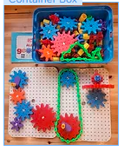  Hazard Identification of Gears box  Quercetti Georello gear set. | - Trapped fingers  - Impact injury  - Injury from flying objects  - Choking hazard  - Strangulation hazard | - Warn children not to put fingers in the mechanism  - Warn children to watch out for others when using items  - Warn children not the launch objects  - Warn children not to put in the mouth  - Warn children not to put chain round their neck
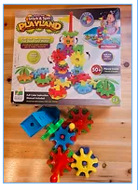  The Learning Journey Techno Kids gear set | - Trapped fingers  - Impact injury  - Injury from flying objects  - Choking hazard  - Strangulation hazard | - Warn children not to put fingers in the mechanism  - Warn children to watch out for others when using items  - Warn children not the launch objects  - Warn children not to put in the mouth  - Warn children not to put chain round their neck
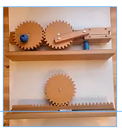  Eisco educational wooden gear | - Trapped fingers  - Injury to foot | - Warn children not to put fingers in the mechanism  - Warn children not to drop on the floor
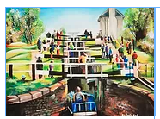  A4 print of Foxton Locks | - Paper cut hazard | - Warn children be careful with handling objects
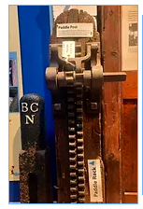  A4 picture of paddle rack | - Paper cut hazard | - Warn children be careful with handling objects
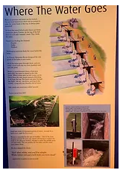  A4 laminated worksheets of gears | - Paper cut hazard | - Warn children be careful with handling objects

