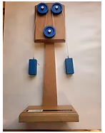  Itemised description of Levers and Pulleys box |   Eisco wooden pulleys. Fixed Pulleys on a mounted wooden stand, interchangeable weights.  Use with a Dynameter (Newton spring) to conduct experiments.  Pulley - Simple Machines — Eisco Labs
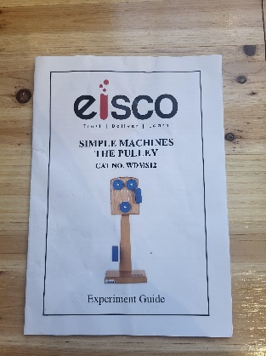 | A4 Eisco instruction booklet and worksheets.
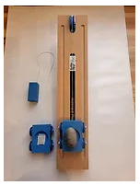 | Eisco wooden incline plane. Wheeled trolley and wooden weights.  Trough on the cart to add different weights, stone example. Wedge shape stand to give alternative angles of slope.  HE1811618 - Simple Machines - Inclined Plane | Hope
 | A4 Eisco instruction booklet and worksheets.
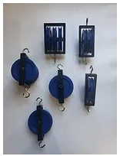 | Eisco aluminium, powder coated pulleys. Hooks on both ends for mounting. 3 types, single, double and triple. Class set of 10.  Single Pulley, 2 Hook - 4.25" x 2" - Mounted in a Heavy Duty Metal Fra — Eisco Labs
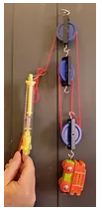 | A4 pulley worksheets with suggested projects.
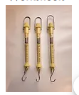 | 3 Dynameters (Newton spring) Plastic case and hooks at either end. 1kg, 10N  B8A40423 - Newton Meter - 1kg, 10N Brown | Philip Harris
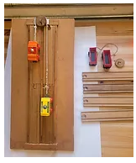 | Build an incline plane set. Wooden fame, jigsaw track, trucks, string and pulley.
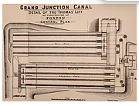 | A4 sheet of Foxton Incline Plane blueprint.  Diagram of how pulleys were incorporated to lift boats up the 75 ft incline plane.
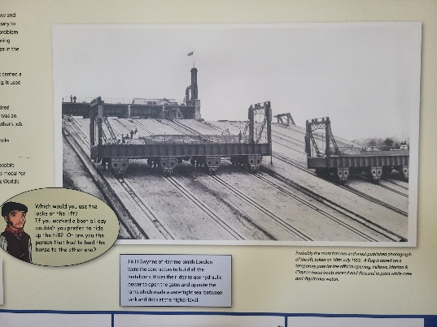 | A4 worksheets about the history of the incline plane.  Suggested links to other examples in history and across the world.
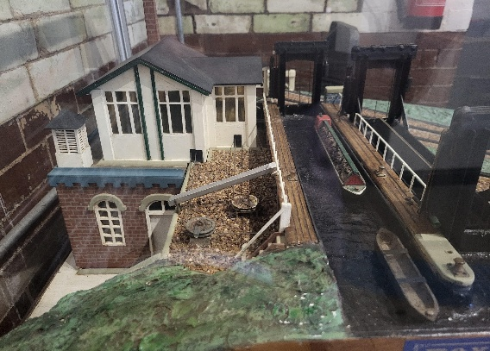 | A4 image of the working incline plane model.  Visitors to the museum can see the model working.  Discover The Boat Lift at Foxton Canal Museum

