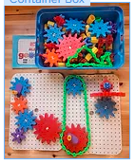  Full itemised description of Gears contents |   Quercetti Georello gear set. 130 pieces in a blue plastic lidded tool box. PLA gears in 4 different sizes, linking adjustable green chain, crank handles, stacking pieces and connecting blocks. A5 instruction booklet with 10 possible setup ideas. 2 peg boards that can be connected. Possible to build flat and upright gear movements.  https://www.amazon.com/Quercetti-Georello-Toolbox-Construction-Gears/dp/B09BDDBDQR
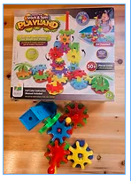 | The Learning Journey Techno Kids gear set. 50 pieces PLA connecting bases in 5 colours, 2 size gears, crank handles, building towers, fun attachable,Eisco gears  flags and trees. Possible to build flat and upright gear movements.  Amazon.com: The Learning Journey Techno Kids - Stack & Spin Playland - STEM Toddler Toys & Gifts for Boys & Girls Ages 2+ Years - Mind Building Preschool Learning Toy : Everything Else
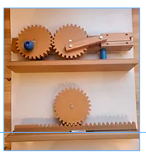 | Eisco educational wooden gear mechanisms, demonstrating rack and pinion, slider movements. Toxic safe MDF, lightweight and safe for children.  Eisco Gear Rack Model Gear Rack Model:Education Supplies, Quantity: Each | Fisher Scientific
 | A4 print of Foxton Locks as educational starting point. Worksheets provided to explain how the history of the site and how the locks work.
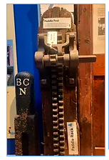 | A4 picture of paddle rack from the museum. Example of rack and pinion that operates the locks. Worksheets to explain how gears are used to open and close the paddles.
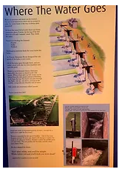 | A4 laminated worksheets of gears in operation at Foxton Locks. Can be photocopied for larger class sets.

