Item  Hazard identification Levers and Pulleys box | Risk |   Control Measure
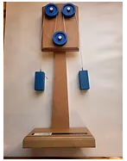  Eisco wooden pulleys. | - Trapped fingers  - Impact injury  - Injury from flying objects  - Choking hazard  - Strangulation hazard | - Warn children not to put fingers in the mechanism  - Warn children to watch out for others when using items  - Warn children not the launch objects  - Warn children not to put in the mouth  - Warn children not to put string round their neck
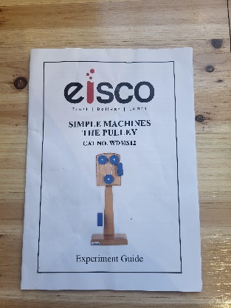  A4 Eisco instruction booklet | - Paper cut hazard | - Warn children to be careful when handling objects
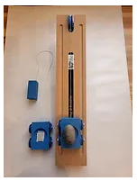  Eisco wooden incline plane | - Trapped fingers  - Impact injury  - Injury from flying objects  - Choking hazard  - Strangulation hazard | - Warn children not to put fingers in the mechanism  - Warn children to watch out for others when using items  - Warn children not the launch objects  - Warn children not to put in the mouth  - Warn children not to put string round their neck
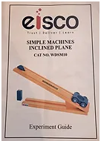  A4 Eisco instruction booklet | - Paper cut hazard | - Warn children to be careful when handling objects
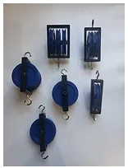  Eisco aluminium pulleys | - Trapped fingers  - Injury from flying objects | - Warn children not to put fingers in the mechanism  - Warn children not the launch objects
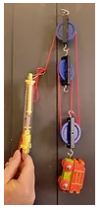  A4 pulley worksheets | - Paper cut hazard | - Warn children to be careful when handling objects
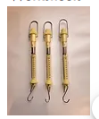  Dynameters (Newton spring) | - Injury from flying objects  - Trapped fingers | - Warn children not the launch objects  - Warn children not to put fingers in the mechanism
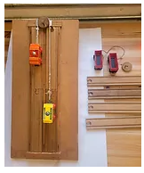  Build an incline plane set | - Trapped fingers  - Impact injury  - Injury from flying objects  - Choking hazard  - Strangulation hazard | - Warn children not to put fingers in the mechanism  - Warn children to watch out for others when using items  - Warn children not the launch objects  - Warn children not to put in the mouth  - Warn children not to put string round their neck
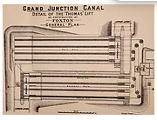  Foxton Incline Plane blueprint | - Paper cut hazard | - Warn children to be careful when handling objects
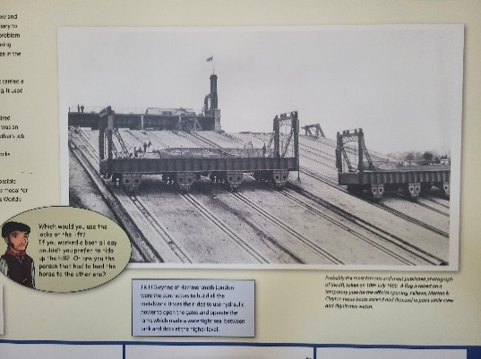  A4 worksheets | - Paper cut hazard | - Warn children to be careful when handling objects
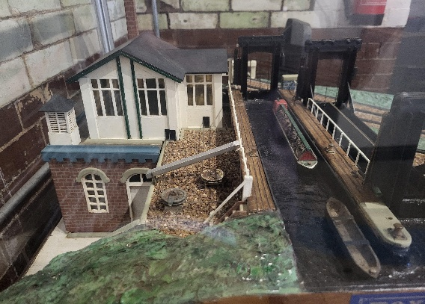  A4 image of working model | - Paper cut hazard | - Warn children to be careful when handling objects

